Database development with SQL

Name of student

Name of professor

University

Course

Date

This task is based on the development of a pet database system. The database pet grooming services consumes three tables that are broken down into three categories that are:

* Owner pet description
* Pet appointments
* Invoice description

The next task is to create these database objects in a DBMS, using the IBM’s DB2 database. We shall use SQL to create the necessary tables for the three above categories. All SQL code for this is also attached.

Creating the tables with metadata:

--CREATING THE OWNER AND PET INFO

CREATE TABLE OWNER_PET_INFO

(

OWNER_ID INT NOT NULL,

OWNER_NAME VARCHAR(255),

PET_NAME VARCHAR(255),

OWNER_ADDRESS VARCHAR(255),

PET_ID INT NOT NULL,

PET_DESCRIPTION VARCHAR(255)

)

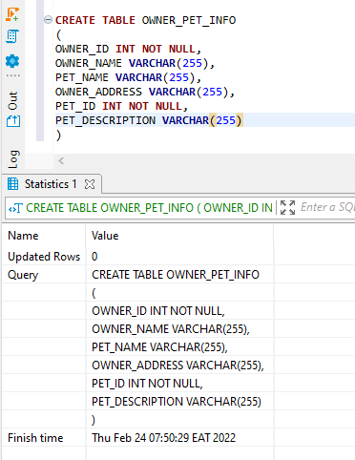

Results after creating the table

INSERT INTO OWNER_PET_INFO (OWNER_ID,OWNER_NAME,PET_NAME,OWNER_ADDRESS,PET_ID,PET_DESCRIPTION)

VALUES('1','SCOTT, BRUCE','COCKER SPANIEL','200 LEMON DRIVE','1',' F, 5 yr., 28 lbs');

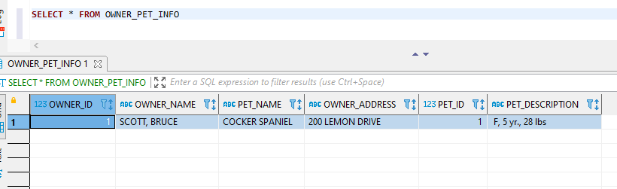

Selecting the table to view data

Then creating the appointments table

--APPONTMNENT TABLE

CREATE TABLE APPOINTMENT_PET_INFO

(

OWNER_ID INT NOT NULL,

OWNER_NAME VARCHAR(255),

PET_NAME VARCHAR(255),

APPOINTMENT_INFO VARCHAR(255),

PET_ID INT NOT NULL,

PET_DESCRIPTION VARCHAR(255),

APPOINTMENT_DATE DATE

)

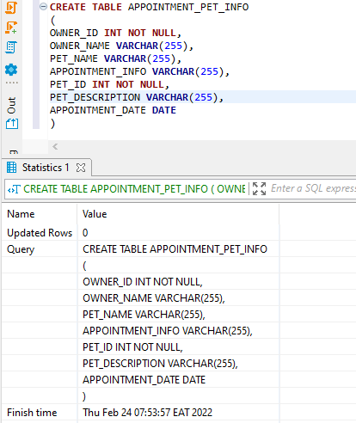

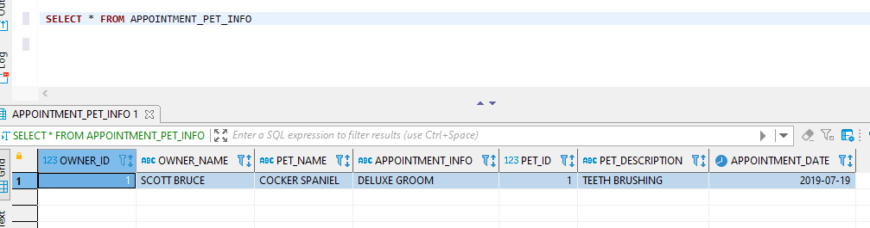

Selecting from the table

Then creating the invoice table

CREATE TABLE INVOICE_INFO

(

OWNER_ID INT NOT NULL,

OWNER_NAME VARCHAR(255),

PET_ID INT NOT NULL,

PET_DESCRIPTION VARCHAR(255),

SERVICE_TYPE VARCHAR(255),

AMOUNT_TOTAL FLOAT,

INVOICE_DECSRIPTION VARCHAR(255),

SERVICE_DATE DATE

)

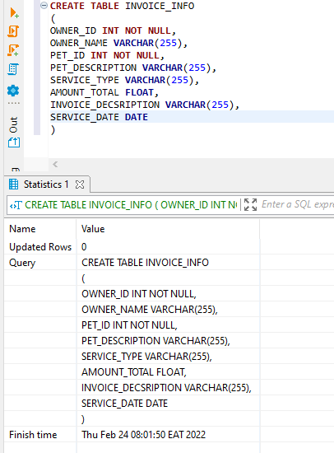

INSERT INTO INVOICE_INFO (OWNER_ID,OWNER_NAME,PET_ID,PET_DESCRIPTION,SERVICE_TYPE,AMOUNT_TOTAL,INVOICE_DECSRIPTION,SERVICE_DATE)

VALUES('1','SCOTT BRUCE','1','F, 5 yr., 28 lbs','TEETH BRUSHING','567','1/15/2021 1:00 PM

(1) STANDARD GROOM - $99.00 (1 hr. 30 min)

(2) TEETH BRUSHING - $39.00 (30 min.)

TOTAL: $138.00 (2 hrs.)

','2018-05-23');

]

Then we query the invoice table to view the invoices

